A gentle introduction to the use stream processors
Erik Zeitler 2007-05-16

“Diamond” topology, with static node count in middle layer

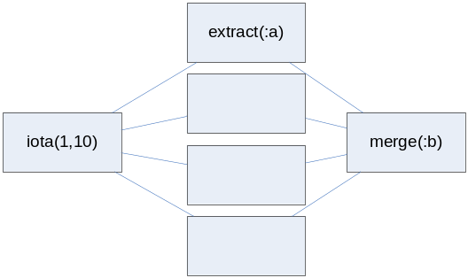

set :a = sp(streamof(iota(1,10)) ,4, "tcp");
set :b = spv(vectorof(select streamof(extract(:a)) from integer i where i=iota(1,4)), "tcp");
merge(:b);

Distribute a set of different queries to be executed over a vector of stream processors in parallel.
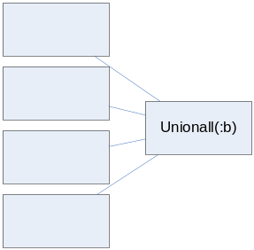

create function queries()->stream as stored;
add queries() = streamof(iota(1,10));
add queries() = streamof(iota(21,30));
queries();

set :a = spv(vectorof(queries()), "tcp");

select extract(:a[i]) from integer i;

Currently, the result is retrieved in the order of the vector elements in :a. I will try to improve this so that elements are extracted whenever they arrive.

set :a = sp(streamof({{1,2},{3,4},{4,5}} ),1, "tcp");
set :b = spv(vectorof(select streamof(extract(:a)) from integer i where i=iota(1,1)), "tcp");
merge(:b);

